

Denton Reads

Film Festival

October 2008
Film Festival Committee
Carmen Grant
Greg Hardin
Kayci Barnett
Brandy Klug
Remington Pohlmeyer
Kim Stanton
Justin Stewart
Sue Parks
Diane Davis
Sponsors
Barnes & Noble
Partners
University of North Texas Libraries
Denton Public Libraries
DISD
Texas Woman’s University Library

Special Thanks
http://dentonreads.unt.edu

UNT Media Library..................(940) 565-2480

UNT Research Park Library....(940) 369-7200

Denton Public Library................(940) 349-8752

TWU Library...............................(940) 898-3701

All film screenings are free and open to the public.

Event Schedule
Location

Event Schedule
Event Schedule
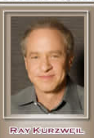 | The Acceleration of Technology in the 21st century: the impact on education and society, Ray Kurzweil  Thursday, October 9, TWU Library, 12pm  The nature of education will change when humans merge with nonbiological intelligence. We don’t yet have communication ports in our biological brains to download the interneuronal connection and neurotransmitter patterns that represent our learning--a profound limitation of the biological paradigm we now use for our thinking that we will overcome. (90 min.)
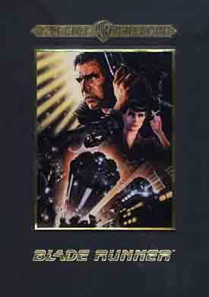 | Blade Runner (1982)  Saturday, October 4, Emily Fowler Library, 3pm  Rick Deckard prowls the steel-and-microchip jungle of Los Angeles in the 21st century. He is known as a "blade runner" who stalks genetically made criminal replicants. His assignment is to terminate their existence. The only crime these cyborgs have committed is wanting to be human. This remastered director's cut differs significantly from what 1982 moviegoers saw. (117 min.) Rated R.
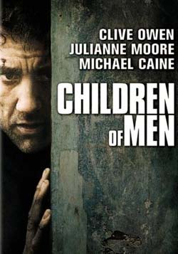 | Children of Men (2007)  Wednesday, October 1, UNT Media Library, 6pm  A futuristic drama set in a world in which humans have lost the ability to reproduce and subsequently face certain extinction. Things change when a single woman mysteriously becomes pregnant, prompting a conflicted government bureaucrat and his ex-wife to join forces to protect her. (110 min.) Rated R.
 | City of Ember (2008)  Saturday, October 11, Denton Cinemark 14, 10:30am  Bill Murray, Tim Robbins and Martin Landau star in this adventure set in Ember, a city illuminated only by artificial light. When the city's generator begins to fail, two teens race to solve an ancient mystery and save Ember's citizens from darkness. Based on author Jeanne Duprau's enchanting children's tale, “City of Ember” stars Harry Treadaway and Saoirse Ronan as the two heroic teens. Rated PG.

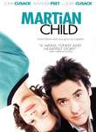 | Martian Child (2007)  Monday, October 13, TWU Library, 7pm  In this film based on a David Gerrold novel, John Cusack stars as a recently widowed science-fiction writer who adopts a 6-year-old boy to quell his loneliness. The catch? The kid claims to be from Mars. At first, the new dad doesn't pay much attention to the boy's story, but when an odd series of events occurs, he begins to believe his son may be telling the truth. (107 min.) Rated PG.
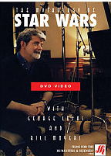 | Mythology of Star Wars (1999)  Tuesday, September 30, UNT Media Library , 6pm  Wednesday, October 1, UNT Media Library, 12pm  Bill Moyers conducts an interview with George Lucas in which he discusses his efforts to tell old myths in new ways, the role of faith in his own life, and the influence of his mentor, Joseph Campbell. (57 min.)
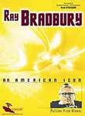 | Ray Bradbury: an American icon (1997)  Thursday, October 2, TWU Library, 12pm  Rod Steiger narrates this profile of science fiction novelist and playwright Ray Bradbury, highlighting the full scope of the writer's five-decade career. Combining footage of Bradbury at home and on the lecture circuit with comments from his friends, family and colleagues, the film provides a detailed overview of Bradbury's career. Also included are Bradbury's own reflections on his life and works and clips from TV's "The Ray Bradbury Theater." (47 min.)
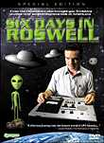 | Six Days in Roswell (1999)  Monday, October 6, TWU Library, 7pm  In 1947, rancher William "Mac" Brazel discovered what looked like a crashed alien spacecraft in Roswell, New Mexico. After he reported his find to the local air base, the wreckage was reportedly whisked away. Whether it exists or not, the U.S. government isn't talking -- but lots of other people are. The filmmakers who brought you Trekkies now take on Roswell; who knows what they'll find?  (81 min.)

Event Schedule
 | Dreams with Sharp Teeth (2006)  Wednesday, October 8, UNT Media Library, 6pm  Directed by Erik Nelson, this absorbing documentary delves into the life of sci-fi scribe Harlan Ellison, known as much for his contentious demeanor and abrasive personality as he is for his award-winning literature. The venerated writer -- one of the genre's most prolific and influential storytellers -- is profiled through accounts of critics, friends and associates, candid interviews with the outspoken author and readings from his works. (97 min.)
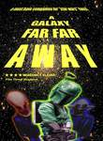 | A Galaxy Far, Far Away (2002)  Tuesday, October 7,UNT Media Library, 6pm  Wednesday, October 8, UNT Media Library, 12pm  "Star Wars" movies have sold more tickets and made more money than any other films in history. This documentary goes deep into what drives this phenomenon through interviews with fans, movie executives, producers and other celebrities to shed new light on the film trilogy that has captivated generations of moviegoers, offering new insight into why these fast-paced science fiction films struck such a powerful chord that crossed race, gender and age lines. (80 min.)
 | Game Over: Gender, Race, and Violence in Video Games  Tuesday, October 14, UNT Media Library, 6pm  Wednesday, October 15, UNT Media Library, 12pm  This educational documentary offers a refreshing dialogue about the complex and controversial topic of video game violence, and is designed to encourage high school and college students to think critically about the video games they play, instead of dismissing the technology as 'harmless fun'.  (41 min.)
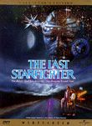 | Last Starfighter (1984)  Thursday, October 9, Denton Library North, 4pm  Alex Rogan lives in a trailer park and spends his days playing the Starfighter video game. Upon meeting an alien who convinces him to use his skills in real combat, Alex heads to space to protect the galaxy from invasion. He gets to the Starfighter base station before deciding the trailer park wasn't so bad, but returns home to find he's being stalked by an alien beast -- and the planet's future is in his hands. (101 min.) Rated PG.

Event Schedule
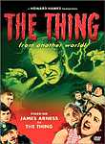 | Thing from Another World (1951)  Saturday, October 11, Denton South Branch Library, 3pm  According to many film fanatics, “The Thing” belongs in the pantheon of science fiction classics. This celluloid chronicle follows a team of scientists and researchers who discover an unclassifiable creature frozen in a block of ice. When the ice thaws, it unleashes a powerful, destructive creature that's bent on annihilating everything in its path. (87 min.)
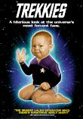 | Trekkies (1999)  Monday, October 6, TWU Library, 8:30pm  From stalwart Starfleet jurors to a minimum of miniature-golfing Klingons, this docu-comedy takes a hilariously breezy and off-kilter look at the "Star Trek" fandom menace. (86 min.)
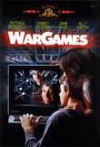 | War Games (1983)  Wednesday, October 15, UNT Media Library, 6pm  After he cracks the security of an Air Force supercomputer, young hacker David Lightman (Matthew Broderick) accidentally tells it to start preparing a preemptive nuclear strike. Combining Cold War paranoia with adolescent adventure, director John Badham's techno-thriller follows Lightman and girlfriend Jennifer (Ally Sheedy) as they travel across the country to try and warn the military of the impending launch. (113 min.) Rated PG.

Denton Reads Film Festival Event Calendar
 | 10 am |  | 11 am | 12 pm |  | 1 pm |  |  | 2 pm | 3 pm | 4 pm |  |  | 5 pm | 6 pm |  | 7 pm |  |  |  | 8pm |  | 9 pm
Sept 30 |  |  |  |  |  |  |  |  |  |  |  |  |  |  | Mythology of Star Wars  @ UNT Media Library
Oct 1 |  |  |  | Mythology of Star Wars  @ UNT Media Library |  |  |  |  |  |  |  |  |  |  | Children of Men  @ UNT Media Library
Oct 2 |  |  |  | Ray Bradbury: An American Icon  @ TWU Library
Oct 3
Oct 4 |  |  |  |  |  |  |  |  |  | Blade Runner  @ Emily Fowler Library
Oct 5
Oct 6 |  |  |  |  |  |  |  |  |  |  |  |  |  |  |  |  | Six Days in Roswell @TWU Library |  |  |  |  | Trekkies @TWU Library
Oct 7 |  |  |  |  |  |  |  |  |  |  |  |  |  |  | A Galaxy Far, Far Away  @ UNT Media Library
Oct 8 |  |  |  | A Galaxy Far, Far Away  @ UNT Media Library |  |  |  |  |  |  |  |  |  |  | Dreams with Sharp Teeth  @ UNT Media Library
Oct 9 |  |  |  | The acceleration of technology in the 21st century  @TWU Library |  |  |  |  |  |  | Last Starfighter  @Denton North Branch Library
Oct 10
Oct 11 |  | City of Ember  @ Denton Cinemark 14 |  |  |  |  |  |  |  | Thing from Another World  @Denton South Branch Library
Oct 12
Oct 13 |  |  |  |  |  |  |  |  |  |  |  |  |  |  |  | Martian Child  @TWU Library
Oct 14 |  |  |  |  |  |  |  |  |  |  |  |  |  |  | Game Over  @ UNT Media Library
Oct 15 |  |  |  | Game Over  @ UNT Media Library |  |  |  |  |  |  |  |  |  |  | War Games  @ UNT Media Library

